DEPI

Team number : 1

Link source : [Students' Social Media Addiction](https://www.kaggle.com/datasets/adilshamim8/social-media-addiction-vs-relationships)

GitHup link: [team1depi · GitHub](https://github.com/team1depi)

Members name :

* Mohamed Mohamed Galal Mohamed
* Yousif Mohammed Saied Mohammed
* Mariam Diaa Salama Haider
* Shahd khalifa abdelmaged ibrahim
* Shahd Yasser Hassan Ali
* Mona Mohamed Abd Elhady Shaheen

**Student social media addiction**

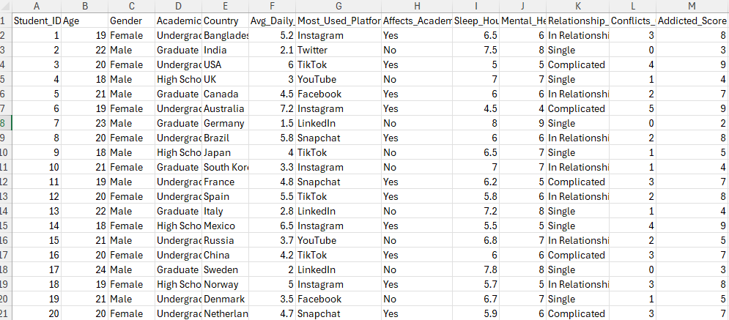

This is the first data we got it to make anylsis.

The team suggested that we add 5 columns.

1-The ages of each group of students and name is “Age Group”.

2-“The sleep category”.

**3-“Addiction Category”**

**4-“Conflict Category”**

**5-“Usage Group”**

Exploring some data :

Objectives

1-most used platform VS Avg daily usage hours :

Users spend **more time on messaging apps** (like WhatsApp) than on content-sharing platforms (like Instagram).  
The difference between the top platforms is moderate but shows **WhatsApp’s strong dominance** in daily engagement.

2- Addiction score by age group:

Younger users (especially those aged **18–20**) show a **higher tendency toward social media addiction**, while the addiction level slightly decreases with age. This suggests that **younger individuals are more engaged and dependent** on digital platforms compared to older users.

3- Examine the relationship between social media addiction and mental health:

There is a **strong inverse relationship** — meaning that **increased social media addiction is associated with poorer mental health**. This suggests that excessive use of social media could negatively impact users’ emotional well-being.

4- Comparison Between Average Usage Hours and Addiction Levels Across Social Media Platforms:

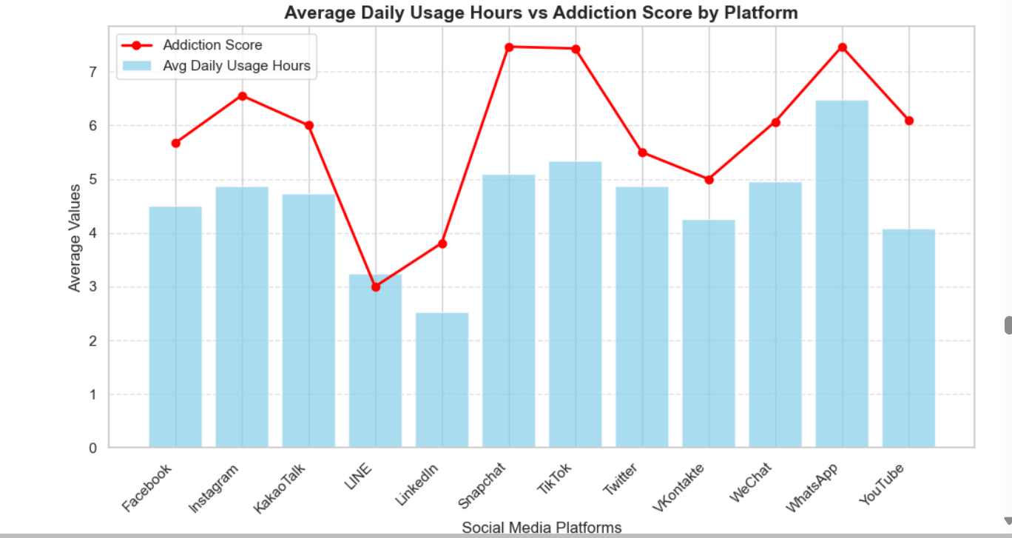

There’s a strong link between daily usage and addiction. Platforms like **TikTok**, **Snapchat**, and **WhatsApp** show the highest addiction and usage levels, while **LinkedIn** and **LINE** have the lowest. **Instagram** and **YouTube** fall in the moderate to high range.

5- Relationship Between Conflict Category and Daily Usage Hours:

The chart shows that people who fall into the **high conflict category** spend the **most time on social media** (around 6 hours daily).  
Those in the **moderate conflict category** use it for about **4.5 hours**, while the **low conflict group** spends the **least time** (around 3 hours).

Most users feel that social media has a **negative or noticeable impact** on their academic achievement.

7- Effect of Relationship Status on Social Media Conflicts:

we can conclude that people with a “Complicated” relationship status tend to experience the highest levels of social media conflicts on average. Those “In a Relationship” report slightly lower conflict levels, while “Single” individuals fall in between. Overall, relationship complexity appears to be associated with more social media conflicts.

8-Role of Social Media in Social Relationships (Conflicts by Category):

we can conclude that most students experience a **moderate level of conflicts** caused by social media. A smaller portion faces **high levels of conflict**, while only a few report **low conflict levels**. This suggests that social media plays a significant but generally moderate role in causing conflicts within social relationships.

9- Number of students affected academically by Sleep Category:

we can conclude that most students with **normal sleep** report being **academically affected** by their sleep habits. Students with **long sleep** show a mix, but a larger number seem **not affected** academically. Meanwhile, students with **short sleep** are fewer overall but are mostly **affected** academically.

10- Assess the combined impact of addiction on students’ mental health:

Students with higher social media addiction tend to have lower mental health scores, while those with low addiction levels show the best mental well-being. This suggests a negative relationship between addiction and mental health.

11- Key numeric variables show how addiction, sleep, and mental health are interrelated:

There is a strong negative correlation between addiction and both sleep (-0.76) and mental health (-0.95), meaning higher addiction is linked to less sleep and poorer mental health. Sleep and mental health are positively related (0.71), suggesting better sleep supports better mental well-being.

12- Students are grouped by social media usage patterns to identify distinct clusters, such as heavy VS moderate users, and compare their behaviors:

Students are clearly divided into low, moderate, and heavy social media users. Heavy users spend more hours online and have higher addiction scores, while low users spend less time and show minimal addiction levels. This highlights how usage intensity strongly influences addiction behavior.